Game Design Document

Fill up the following document

1. Write the title of your project.

The Space game

1. What is the goal of the game?

To complete 3 levels

1. Write a brief story of your game.

Shila is a girl who from her childhood wanted travel in space and now that she is grown up is travelling with her spaceship in the space and looking for wonders …

1. Which are the playing characters of this game?

* Playing characters are the ones who respond to the user based on the input from the user.
* Cars, monkeys, dinos, wizards, etc., are the playing characters in the game.

|  |  |  |
| --- | --- | --- |
| Number | Character Name | What can this character do? |
| 1 | Space ship | Move with the arrow keys and collect coins. |
| 2 |  |  |
| 3 |  |  |
| 4 |  |  |
| 5 |  |  |
| 6 |  |  |
| 7 |  |  |
| 8 |  |  |

1. Which are the Non-Playing Characters of this game?

* Non-Playing characters are the ones that don't have an action or behavior when the user interacts with the game.
* Hurdles, stones, bananas, coins, etc., are non-playing characters in the game.

|  |  |  |
| --- | --- | --- |
| Number | Character Name | What can this character do? |
| 1 | Coins | They are to be collected |
| 2 | Comets in level 1 . | They attack the spaceship from level 1 |
| 3 | Meteros in level 2 . | They attack the spaceship from level 2 |
| 4 | Opponent spaceships in level 3 . | They attack the spaceship from level 3 |
| 5 |  |  |
| 6 |  |  |
| 7 |  |  |
| 8 |  |  |

Draw your imagination of this game. What does this game look like?

* Draw the game either on your computer or on paper.
* Add images of the game scenes to show each of the playing and non-playing characters at least once.

In next slide

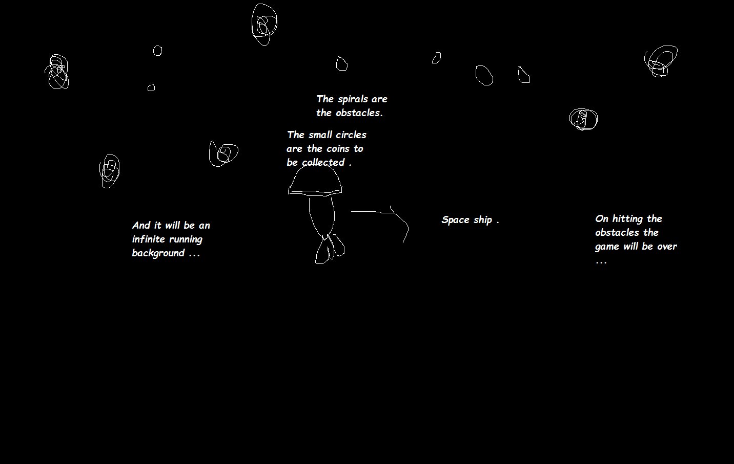

How do you plan to make your game engaging?

By adding on obstacles and levels …